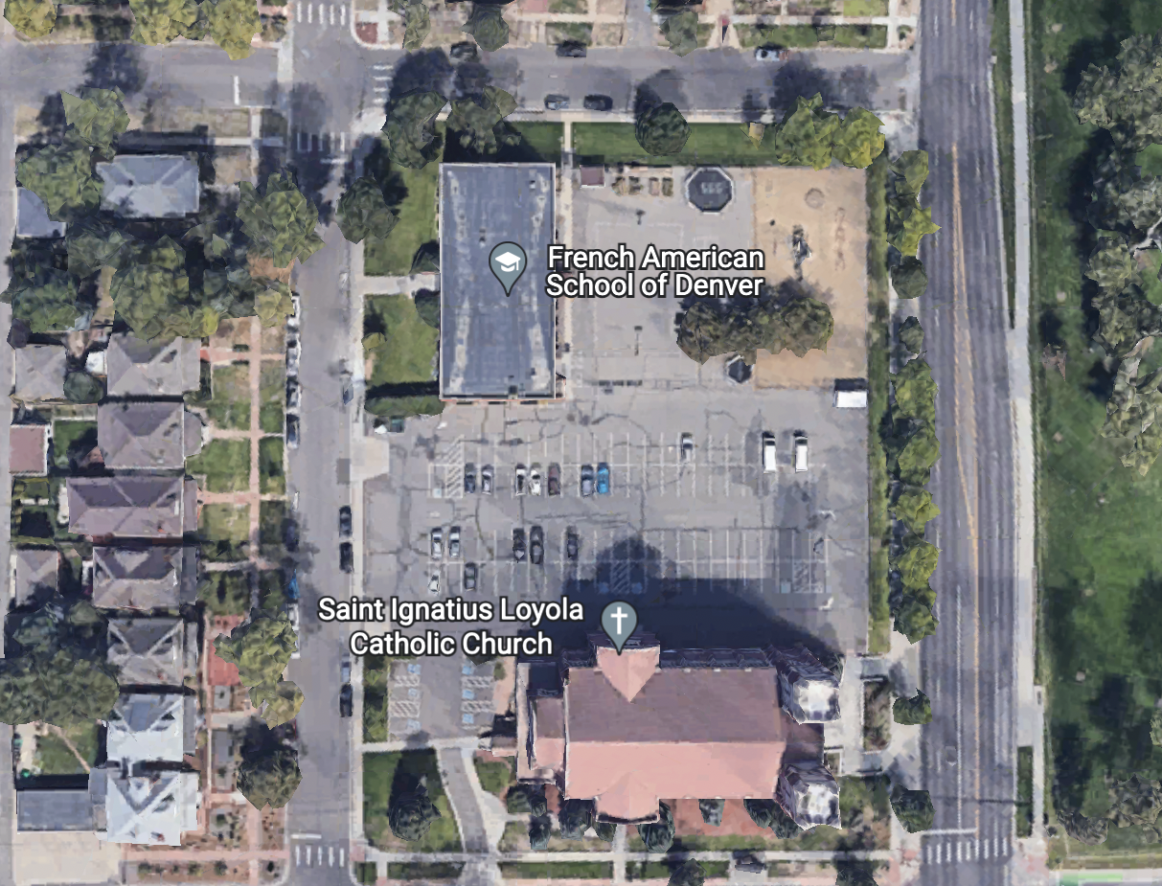
Walking students enter thru Main Entrance
York Street

Students walk thru gate and enter the school
N. Gaylord Street

24th Avenue

Pick-Up and Drop-Off Route:

Heading north on Gaylord Street, turn right to enter the parking lot. Follow the route around the parking lot to the pick-up/drop-off area spaces indicated by [ ] on the map. (There will be staff members present to receive and provide guidance to arriving/departing students.). Exit the parking lot (right turn only). Entrance and exit into the parking lot is via right turns only to allow for easy access and smooth flow with minimal impact to traffic on Gaylord. This will help reduce the time it takes for Pick-Up and Drop-Off each day.

Walkers: Please park along the streets surrounding the school, leaving the parking lot for the steady flow of cars (Please do not park directly in front of the school.)
- AM Drop-Off for Walkers: Ring the doorbell to the right of the Main Entrance door to be admitted to the school.
- PM Pick-Up for Walkers: Via PikMyKid app, announce your arrival and that your child is a “Walker”. Your child will leave from the Main Entrance to meet you outside where a staff member will check out your student to you or your designee.

